NAAN MUDHALVAN ASSIGNMENT DOCUMENT

**COURSE TITLE** : DIGITAL MARKETING

**COLLEGE CODE** 1105

**COLLEGE NAME** : GOJAN SCHOOL OF BUSINESS AND TECHNOLOGY

**NM ID** : 8DCD502C9FA011BABB842D8CD53E1EC9

**NAME** : DEKONDA REVATHI

**REGISTER NUMBER** 110520106001

**YEAR** : 4TH YEAR

**DEPARTMENT** : ELECTRONICS AND COMMUNICATION ENGINEERING

1. Create a blog or website using Blogspot and Wordpress. Customize the theme design and post new article with 500 words.

Link: <https://clothinghub123.blogspot.com/2023/10/clothing-hub.html>

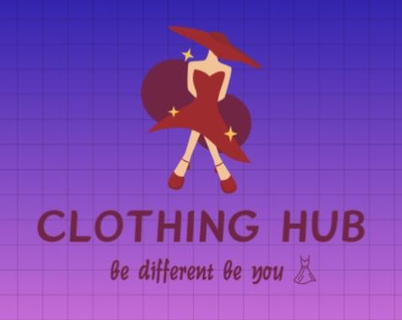

1. Create a New Facebook Business Page and post one social media poster for your brand.

Link: [https://www.facebook.com/people/Clothingo-](https://www.facebook.com/people/Clothingo-Phile/pfbid0dRoSVeTLUFQPuqKWaz4rNLD56zWuKsrGFMFN4KweThbB1SGU3B2a3wAwCU6EYbx9l/?mibextid=ZbWKwL) [Phile/pfbid0dRoSVeTLUFQPuqKWaz4rNLD56zWuKsrGFMFN4KweThbB1SGU3B2a3wA](https://www.facebook.com/people/Clothingo-Phile/pfbid0dRoSVeTLUFQPuqKWaz4rNLD56zWuKsrGFMFN4KweThbB1SGU3B2a3wAwCU6EYbx9l/?mibextid=ZbWKwL) [wCU6EYbx9l/?mibextid=ZbWKwL](https://www.facebook.com/people/Clothingo-Phile/pfbid0dRoSVeTLUFQPuqKWaz4rNLD56zWuKsrGFMFN4KweThbB1SGU3B2a3wAwCU6EYbx9l/?mibextid=ZbWKwL)

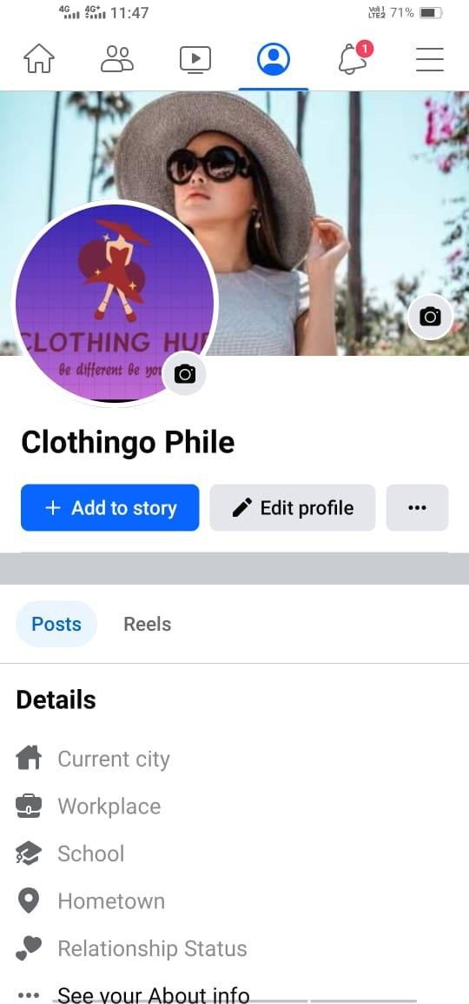

1. 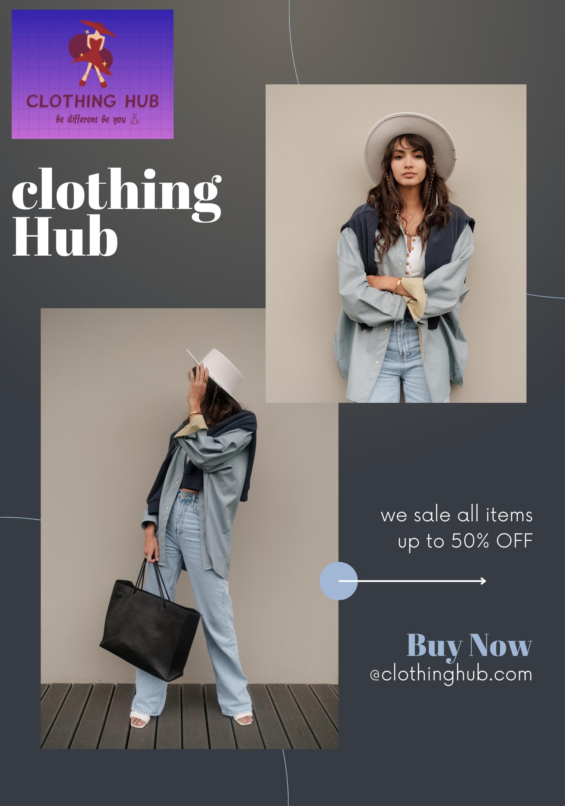Create and design a social media advertisement poster using canva.
2. Create email newsletter design using MailChimp or canva tool.

Link: [https://www.canva.com/design/DAFx5WGbdug/KjCk40t5f6c3SqrfSHDFkw/view?utm_content](https://www.canva.com/design/DAFx5WGbdug/KjCk40t5f6c3SqrfSHDFkw/view?utm_content=DAFx5WGbdug&utm_campaign=designshare&utm_medium=link&utm_source=editor)

[=DAFx5WGbdug&utm_campaign=designshare&utm_medium=link&utm_source=editor](https://www.canva.com/design/DAFx5WGbdug/KjCk40t5f6c3SqrfSHDFkw/view?utm_content=DAFx5WGbdug&utm_campaign=designshare&utm_medium=link&utm_source=editor)

